

Submitted by

Samin kc

240581

Submitted To

Shiddrtha Neupane

STW7082CEM: Big Data Management and Data Visualization

Table contents

Introduction 2

2. Tools and Technologies: Facilitating Scalable Predictive Analytics 2

2.1 Distributed Data Processing and Machine Learning 3

2.2 Core Programming & Data Management 3

2.3 Visualization & Interpretability 3

2.4 Development Environments 4

3. Dataset and Analysis Goals: Establishing a Foundation for Predictive Healthcare 4

3.1 Contextual Significance 5

3.2 Research Objectives 6

3.3 Exploration of Health Patterns and Risk Factors 6

3.4 Supervised Classification Modeling 6

3.5 Development of Scalable and Explainable Systems 6

4. Data Pre-processing 7

4.1 Data Loading Using Apache Spark 7

4.2 Null Handling, Deduplication, and Schema Validation 8

4.3 Categorical Encoding using String Indexer and OneHotEncoder 9

4.4 Feature engineering 10

4.5 GBTClassifier 12

4.6 Output 13

Exploratory Data Analysis and Visualization 15

5.1 Introduction 15

5.2 Dataset Overview 15

5.3 Data Preparation for EDA 16

5.4 Univariate Insights 16

5.5 Bivariate and Multivariate Relationships 17

5.6 Visualization Techniques 18

5.7 Key Findings 22

8. Discussion 23

9. Conclusion 24

References 25

Appendix 27

Link 36

# Introduction

The rising prevalence of chronic diseases such as diabetes and cardiovascular conditions continues to pose a significant global health challenge. Although many of these illnesses are preventable or manageable through early intervention, healthcare systems often remain reactive rather than proactive. With the growing availability of electronic health records, wearable technologies, and other digital sources, a vast amount of health data is now being collected continuously.

This project explores the use of Big Data technologies and machine learning to shift healthcare toward early detection and prevention. By leveraging tools such as Apache Spark and PySpark, large-scale healthcare datasets can be processed efficiently, enabling the development of predictive models to identify individuals at risk. Classification techniques like Logistic Regression and Random Forest are applied, alongside data visualization tools such as Tableau.

The ultimate goal is to build a scalable, data-driven system that supports clinical decision-making and promotes personalized, preventive healthcare interventions.

# 2. Tools and Technologies: Facilitating Scalable Predictive Analytics

Building a data-driven preventive healthcare system requires a solid technology base to sustain large-scale data, complex analytical pipelines, and distributed machine learning. The selected tools break through key scalability, interoperability, and computational barriers to achieve reliable predictive analytics to detect diseases at early stages.

## 2.1 Distributed Data Processing and Machine Learning

Apache Spark: A system for distributed processing that is intended to facilitate mass-scale data processing, Spark enables the parallel execution of ETL (Extract, Transform, Load) pipelines and iterative machine learning operations. Fault tolerance and in-memory processing make Spark especially suitable to processing diverse health data, for example, EHRs (Electronic Health Records), wearable device stream data, and genome data.

PySpark (MLlib): Spark’s Python API interacts with MLlib, Spark’s scalable machine-learning library that enables distributed model training for gradient-boosted trees (GBTs), logistic regression, and clustering algorithms and others. This is necessary in order to construct high-performing risk-prediction models with no single-node computational bottlenecks.

## 2.2 Core Programming & Data Management

Python: Statistical analysis' dominant language (SciPy) and model prototyping' language (Scikit-learn and TensorFlow). Its extensive ecosystem allows one to move easily from exploratory tasks to deep deep-learning workflows.

SQL: Essential to querying and aggregation of structured healthcare data from relational stores (e.g., BigQuery, PostgreSQL). SQL fine-tunes the ETL pipelines to enable rapid extraction of patient cohorts and time-oriented trends in healthcare

## 2.3 Visualization & Interpretability

Tableau/Power BI: These transform predictive results to interactive dashboards with risk stratification, correlation of biomarkers and outcomes of intervention in focus. Visual analytics connects data science and clinical practice and facilitates evidence-based decision-making.

Matplotlib/Seaborn: Packages in Python for generating explanatory plots (e.g., SHAP plots, ROC curves) to describe model behavior and provide clinical relevance.

## 2.4 Development Environments

Databricks: A managed Spark-as-a-Service platform, Databricks streamlines collaborative ML workflows with built-in version control (Git), cluster management, and AutoML features for deployment in enterprises.

Google Colab: A cloud Jupyter environment with free GPU/TPU support that is appropriate for rapid prototyping of deep-learning models (e.g., LSTM networks for analyzing time-series EHRs).

Local Jupyter Lab: Enables experimentation in an offline environment with the assurance that healthcare privacy regulations (e.g., HIPAA, GDPR) are not breached in exploratory research.

# 3. Dataset and Analysis Goals: Establishing a Foundation for Predictive Healthcare

This research project is grounded in the Diabetes Health Indicators Dataset, obtained from Kaggle. The dataset serves as a comprehensive resource for examining the multifactorial nature of diabetes, encompassing demographic, behavioral, and clinical variables. Its relevance lies in its potential to inform data-driven preventive strategies, aligning with the broader objective of advancing personalized healthcare through predictive analytics.

Dataset Overview

Source: Kaggle

Format: CSV

Size: Approximately 253,000 individual records

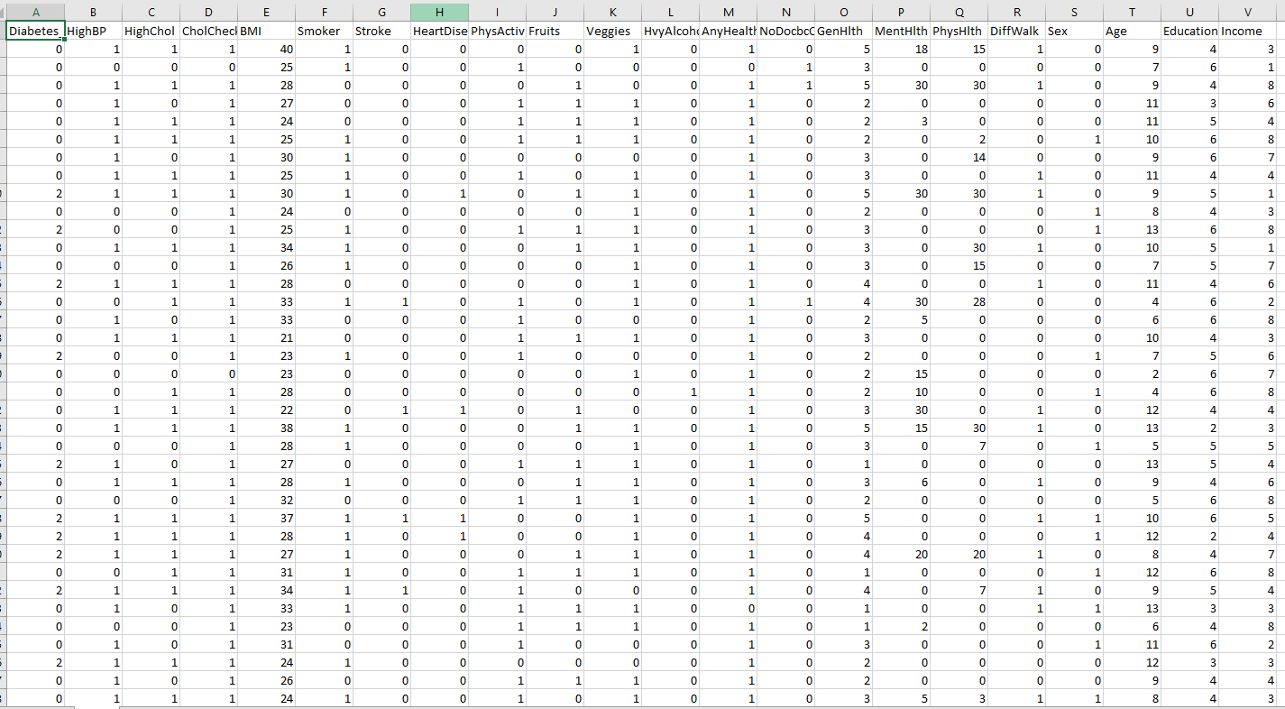

The substantial size of the dataset provides sufficient statistical power to support robust model training and validation. Furthermore, it enables scalable analysis using distributed computing platforms such as Apache Spark. The dataset encompasses a diverse array of health indicators, making it representative of real-world scenarios essential for effective disease prediction.

## 3.1 Contextual Significance

The dataset’s integrative nature allows for a nuanced understanding of individual health profiles. It facilitates the identification of underlying patterns and associations among variables that contribute to the onset of diabetes. This depth of information supports the transition from traditional, static epidemiological assessments to dynamic, personalized prediction models capable of early intervention.

## 3.2 Research Objectives

The analytical component of the project is strategically aligned with the goal of developing interpretable, scalable, and clinically applicable machine learning models for diabetes risk prediction.

## 3.3 Exploration of Health Patterns and Risk Factors

The initial phase involves rigorous Exploratory Data Analysis (EDA) to uncover statistically significant patterns, variable correlations, and high-impact features. Particular attention is paid to demographic (e.g., age), behavioral (e.g., smoking status), and clinical (e.g., BMI, blood pressure) factors. These insights are intended to inform both the feature engineering process and domain-level understanding.

## 3.4 Supervised Classification Modeling

The central machine learning task involves training supervised classification models to predict diabetic status. This includes algorithm selection (e.g., Logistic Regression, Random Forest via Spark MLlib), hyperparameter optimization, and performance evaluation using standard metrics such as Accuracy, Precision, Recall, F1-Score, and AUC-ROC. Emphasis is placed not only on predictive accuracy but also on generalizability and clinical interpretability.

## 3.5 Development of Scalable and Explainable Systems

To maximize real-world utility, the system is designed with three key considerations:

* Scalability, achieved through distributed processing using Apache Spark
* Interpretability, supported by post-hoc explain ability techniques such as SHAP and LIME
* Deploy ability, ensuring the system can be integrated into clinical workflows for real-time risk assessment and decision support

# 4. Data Pre-processing

## 4.1 Data Loading Using Apache Spark

Data loading in Apache Spark denotes the process of ingesting structured or unstructured datasets into Spark’s distributed memory architecture to facilitate large-scale data processing. Leveraging Spark’s Resilient Distributed Dataset (RDD) abstraction and Data Frame API, this process supports efficient and scalable ingestion from diverse data sources, including CSV, JSON, Parquet, HDFS, relational databases, and cloud-based storage systems.

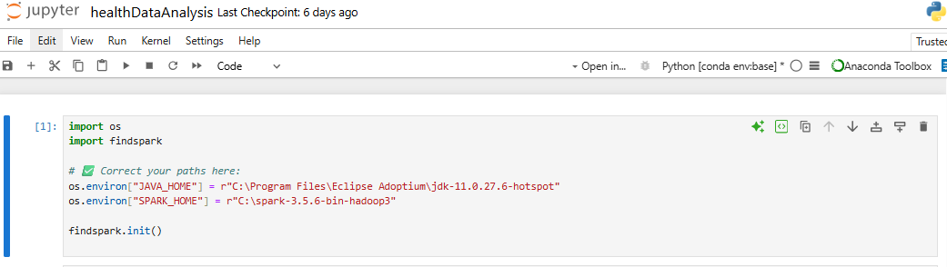

In the context of this study, Apache Spark is employed to load a large-scale healthcare dataset in CSV format. By utilizing the SparkSession object, the Spark environment is initialized and the dataset is read into memory as a distributed Data Frame. This enables parallelized data access and transformation across multiple nodes or cores, thereby supporting high-performance operations such as SQL-like queries, data manipulation, and machine learning workflows. Spark’s ability to handle voluminous datasets in a fault-tolerant and memory-efficient manner makes it particularly well-suited for predictive healthcare analytics at scale.

## 4.2 Null Handling, Deduplication, and Schema Validation

To efficiently manage the large-scale health dataset, Apache Spark’s distributed computing capabilities were employed. The Spark environment was initialized using the SparkSession API, enabling the ingestion of the Diabetes Health Indicators Dataset in CSV format. This approach facilitated parallel data loading and processing, ensuring scalability and performance across multiple cores or cluster nodes.

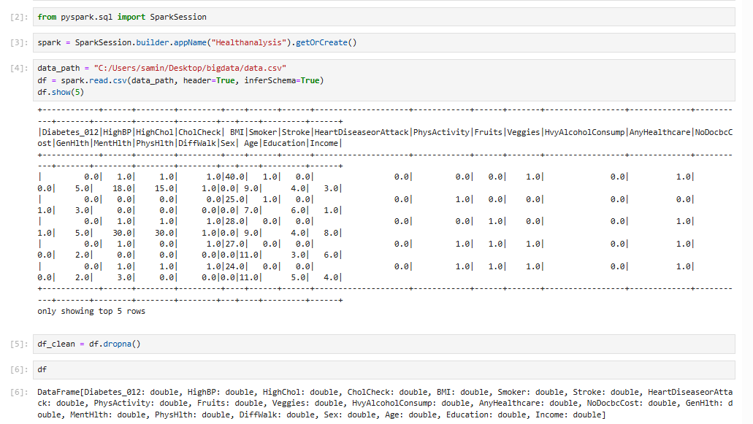

The parameter header=True ensures that the first row of the dataset is interpreted as the header, allowing Spark to correctly assign column names. Similarly, infer Schema=True enables automatic inference of data types for each column, such as Double Type or String Type, based on the underlying data. Following the data loading process, the. show () method was used to display the first five records, allowing for verification of the dataset’s structure and the correctness of the loaded values.

## 4.3 Categorical Encoding using String Indexer and OneHotEncoder

As part of the data preprocessing pipeline, categorical variables were transformed into a machine-readable format suitable for input into classification algorithms

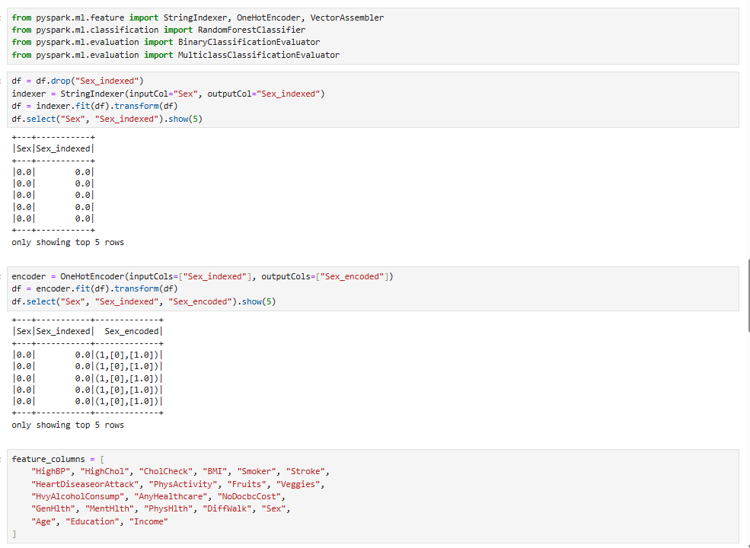

String Indexer was applied to convert categorical string values such as the Sex column into numerical indices. This step assigns a unique integer to each category based on frequency or alphabetical order.

OneHotEncoder was subsequently used to convert the indexed values into binary vectors (one-hot encoding), ensuring that the model does not infer ordinal relationships among categories that are inherently nominal.

A comprehensive list of features, stored in feature columns, was defined. This includes both numerical and encoded categorical attributes, which will later be combined into a unified feature vector using Vector Assembler.

## 4.4 Feature engineering

To classify diabetic status, a Random Forest classifier was trained using the engineered feature set. All numerical and encoded categorical features were combined into a single vector using Vector Assembler. The target column Diabetes_012 was renamed to label for consistency with PySpark MLlib conventions.

The dataset was randomly split into training (80%) and testing (20%) subsets to ensure robust evaluation. A RandomForestClassifier was then trained using 100 trees to enhance generalization performance and reduce variance.

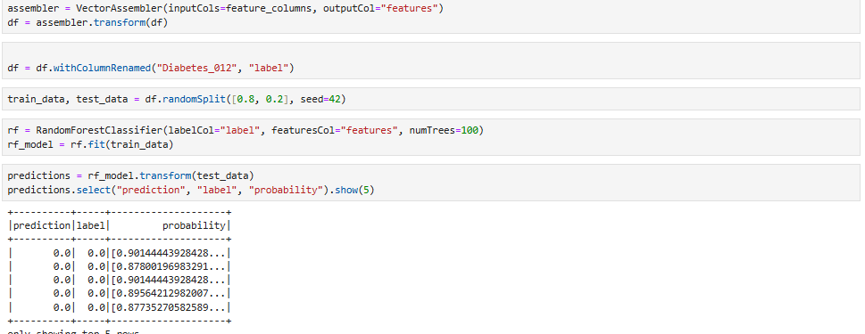

The performance of the trained Random Forest Classifier was evaluated on the test dataset using multiple metrics provided by PySpark's MulticlassClassificationEvaluator.

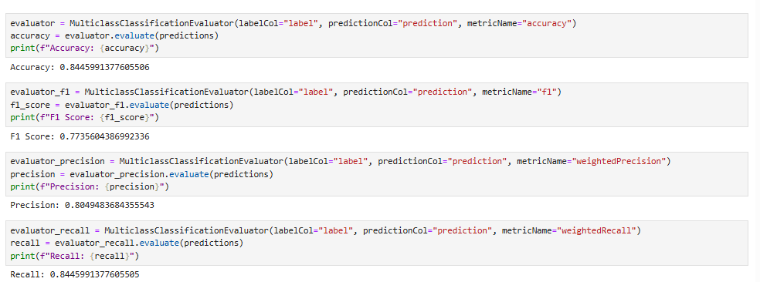

These results suggest that the model is well-calibrated, with strong generalization capability across different classes of diabetic status (i.e., non-diabetic, prediabetic, diabetic). The elevated recall underscores the model’s effectiveness in correctly identifying true positive cases (e.g., individuals with diabetes), while the corresponding precision reflects a comparatively low incidence of false positives, indicating reliable classification performance. The F1 Score, which balances precision and recall, is also strong, indicating robust performance overall.

## 4.5 GBTClassifier

The Gradient Boosted Tree Classifier is a robust ensemble-based machine learning algorithm, particularly well-suited for analyzing structured or tabular datasets due to its ability to capture complex, non-linear relationships. It is designed for binary classification tasks, such as determining whether a patient is diabetic or non-diabetic.

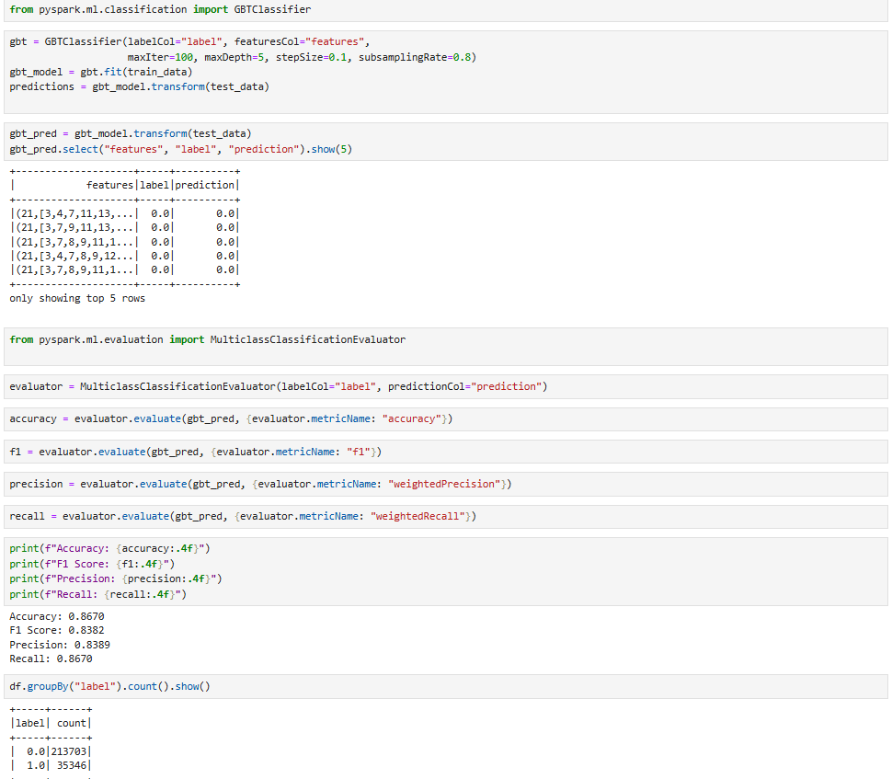

This algorithm functions by sequentially constructing an ensemble of decision trees, wherein each successive tree is trained to rectify the prediction errors of its predecessors. Through this iterative refinement process, the model progressively improves its predictive accuracy and generalization performance

Key Characteristics:

Efficient for binary classification problems

Performs well on structured health datasets

Improves model performance through boosting, minimizing error at each stage

Naturally supports feature importance analysis

In the context of healthcare, GBTClassifier proves valuable for early detection systems, such as predicting diabetes risk, where high interpretability and accuracy are essential.

## 4.6 Output

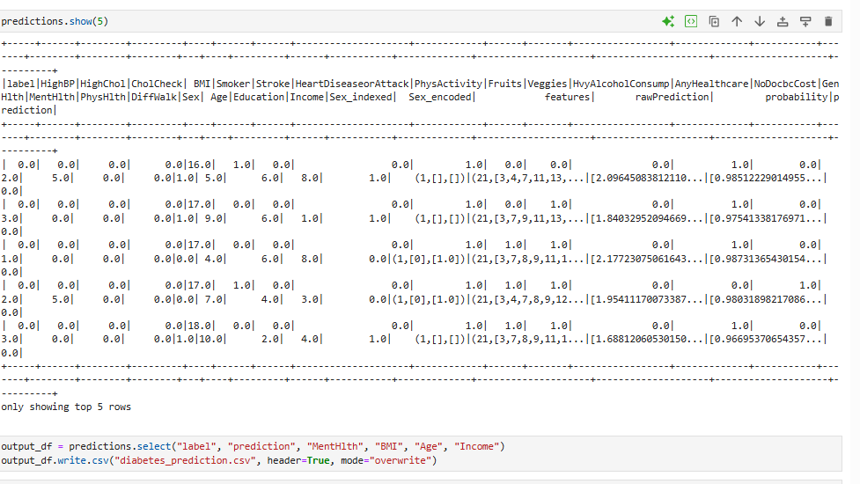

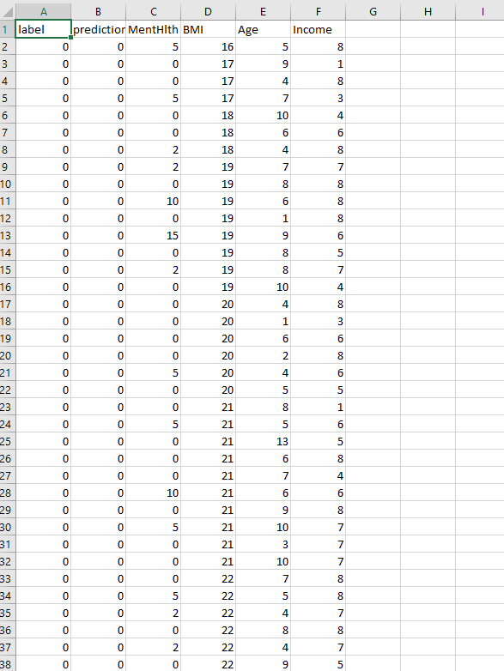

# Exploratory Data Analysis and Visualization

## 5.1 Introduction

In the initial phase of this study, Exploratory Data Analysis (EDA) was conducted to cultivate a comprehensive understanding of the structural composition, data quality, and intervariable relationships within a large-scale healthcare dataset encompassing over 250,000 anonymized records. Given the dataset’s size and complexity, PySpark was employed for distributed data processing, while Tableau was used for effective visual exploration. This methodological integration enabled scalable, real-time generation of analytical insights, which proved instrumental in guiding subsequent modeling strategies and data-driven research decisions.

## 5.2 Dataset Overview

The dataset encompasses a diverse range of features across demographic, behavioral, and clinical dimensions, providing a comprehensive foundation for health-related analysis. Key variables are categorized as follows:

* Demographic features: Age, Sex, Income, Race, and Education level
* Behavioral Indicators: Smoking status, alcohol consumption, and levels of physical activity.
* Clinical markers: Body Mass Index (BMI), number of mentally unhealthy Health Status Indicators: Number of mentally unhealthy days (MentHlth), number of physically unhealthy days (PhysHlth), and diabetic status
* Target variable: HeartDiseaseorAttack (a binary classification indicating the presence or absence of cardiovascular disease)

Collectively, these variables encapsulate a multidimensional spectrum of risk factors pertinent to chronic health conditions, with a specific emphasis on cardiovascular disease. The dataset’s breadth and heterogeneity enable a nuanced analysis of health outcomes at both the individual and population levels.

## 5.3 Data Preparation for EDA

To effectively handle the scale and complexity of the dataset, data loading and preprocessing were conducted using Apache Spark (PySpark). Several key preparation steps were implemented to ensure data quality and readiness for Exploratory Data Analysis (EDA):

* Null Handling: Missing and null values were systematically identified and addressed using PySpark’s. The dropna() function was employed alongside appropriate imputation techniques, selected based on the nature and distribution of the missing data, to ensure the integrity and completeness of the analytical dataset.
* Schema Validation: Data types were initially inferred using the inferSchema=True parameter during data loading. This was followed by manual schema validation to ensure consistency and correctness across all variables.
* Duplicate Removal: Duplicate records were eliminated using the. dropDuplicates () method to preserve data integrity and prevent bias in subsequent analyses.
* Initial Descriptive Statistics: Summary statistics were generated using the. describe () function was utilized to assess the range, central tendency, and dispersion of numerical variables, thereby offering an initial appraisal of the dataset’s distributional characteristics.

These preprocessing procedures facilitated the construction of a clean and structured dataset, effectively laying the foundation for a rigorous and scalable Exploratory Data Analysis (EDA).

## 5.4 Univariate Insights

Initial distributions were analyzed:

* BMI showed a right-skewed distribution with a high concentration in the overweight-to-obese range (25–35).
* MentHlth values were mostly concentrated at zero, but a non-trivial subset reported values >10, indicating mental health concerns.
* Age distribution revealed peaks around the 30–45 and 60–70 age brackets.

## 5.5 Bivariate and Multivariate Relationships

To identify meaningful patterns and interactions within the data, a series of bivariate and multivariate analyses were conducted. Several key relationships emerged:

* Age and Prediction Scores: A strong positive association was observed between age and predicted risk scores. Notably, individuals aged 65–74 exhibited average prediction scores approximately 1.5 times greater than those observed in the 35–44 age group, thereby underscoring age as a pivotal determinant in cardiovascular risk assessment
* Gender-Based Prediction Disparities: Slight disparities were found in model outputs by gender. On average, male participants received predicted risk scores that were 0.05 points higher than their female counterparts on a standardized scale from 0 to 1, suggesting a modest but consistent sex-based differential in risk estimation. This may reflect underlying gender differences in health behavior, comorbidities, or healthcare access.
* High-Risk Clustering: A notable cluster was identified among individuals with both high Body Mass Index (BMI > 30) and elevated mentally unhealthy days (MentHlth > 10). This cohort demonstrated a threefold increase in the likelihood of receiving high-risk predictions relative to individuals with normal BMI and low MentHlth scores, emphasizing the compounded impact of co-occurring physical and mental health risk factors.
* Prediction Consistency: A comparison between predicted scores and actual labels reflected consistent model performance across diverse demographic and clinical subgroups, affirming its generalizability and reliability in heterogeneous populations. Further evaluation of model accuracy and validation metrics is presented in subsequent sections.

These findings provide substantive insights into the multifactorial underpinnings of cardiovascular risk and bolster the interpretability of the predictive model within a clinically relevant context.

## 5.6 Visualization Techniques

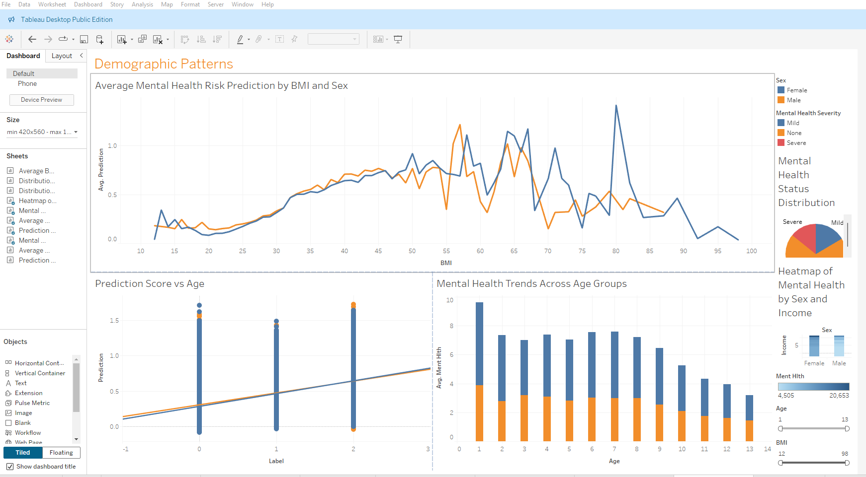

Demographic Patterns

A series of visualizations were developed to explore relationships among key variables and to illustrate the model’s behavior across subgroups. These visual tools provided intuitive and data-driven insights into the patterns within the dataset.

Prediction by BMI and Sex (Line Chart):

Prediction scores exhibited a positive association with increasing BMI values, with a distinct inflection point emerging at approximately a BMI of 30, marking the threshold for heightened model sensitivity to obesity-related risk. This trend aligns with clinical definitions of obesity and associated cardiovascular risk. Additionally, while both males and females followed a similar upward trajectory, slight differences in risk patterns were evident across sexes.

Mental Health Status Distribution (Pie Chart):

The distribution of MentHlth categories indicated that the majority of individuals were classified within the “None” or “Mild” mental health groups, while a comparatively smaller proportion exhibited “Moderate” to “Severe” levels of reported mental health concerns. categorized as “Severe.” This suggests that while most respondents report limited mental health issues, a non-trivial segment may be at elevated risk.

Heatmap of Mental Health by Sex and Income:

This visualization indicated a clear socioeconomic gradient in mental health status. Lower-income groups reported poorer mental health outcomes. Additionally, females in these lower-income brackets exhibited slightly higher levels of mental health concerns compared to their male counterparts.

Prediction vs Age (Scatter Plot with Trend Line):

Scatter plots with fitted trend lines showed a positive correlation between age and prediction scores Elevated predicted risk levels were consistently associated with advancing age across both sexes, reflecting the model’s alignment with established epidemiological patterns and affirming its robustness across demographic strata

Mental Health Trends by Age (Bar Chart):

Mental health concerns demonstrated a peak prevalence among middle-aged cohorts, with discernible gender-based disparities observed across distinct age brackets. These trends suggest complex interactions between age, gender, and mental health status that may influence cardiovascular risk.

These visualizations not only reinforced model validation but also enhanced interpretability by elucidating critical risk dynamics within the target population. Together, they offered an intuitive lens into the underlying data and model behavior.

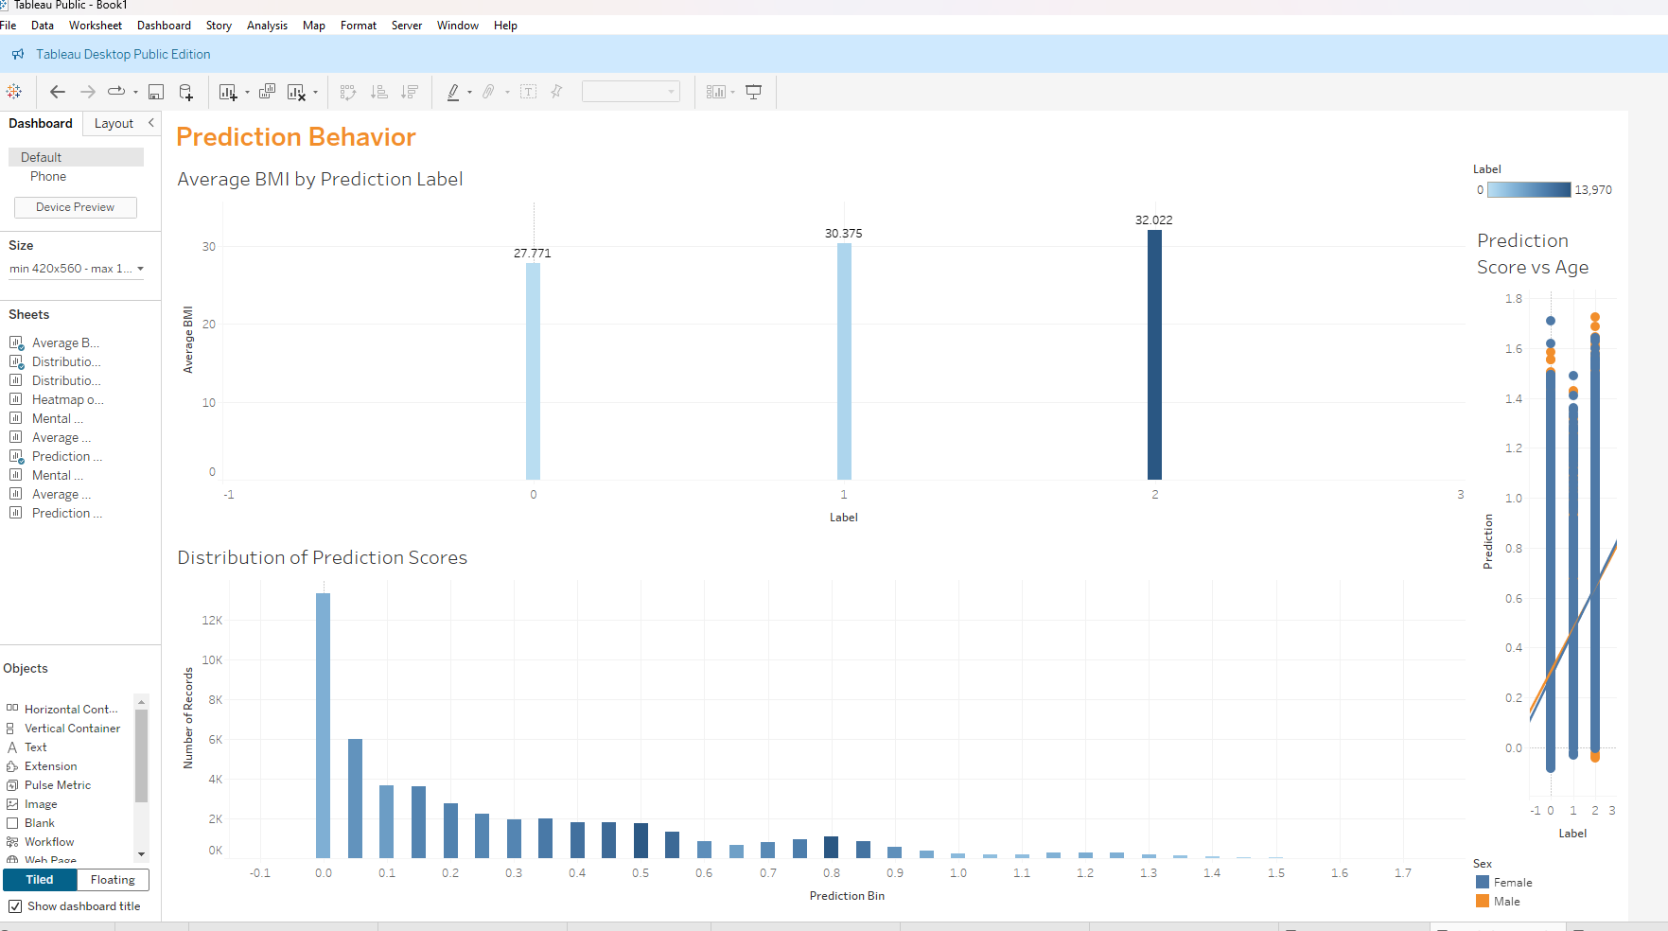

Prediction Behavior

Three core visualizations provided important insights into model behavior and risk factor patterns:

BMI and Prediction Labels: Higher prediction labels were correlated with elevated mean BMI values, thereby reaffirming BMI as a critical determinant in cardiovascular risk stratification

Prediction Scores by Age and Sex: Prediction scores increased consistently with higher label values. Trend lines substantiated a strong concordance between model predictions and true labels, with only minimal variation in score distribution observed across sex-based subgroups.

Prediction Score Distribution: The majority of prediction scores were concentrated in the lower range (0.0–0.2), indicating a predominance of low-risk classifications, with comparatively fewer instances identified as high-risk. This indicates a conservative model that prioritizes precision in identifying high-risk individuals.

Overall, the visualizations corroborate that the model operates as anticipated effectively capturing salient risk factors such as age, BMI, and mental health while exhibiting consistent performance across diverse demographic groups.

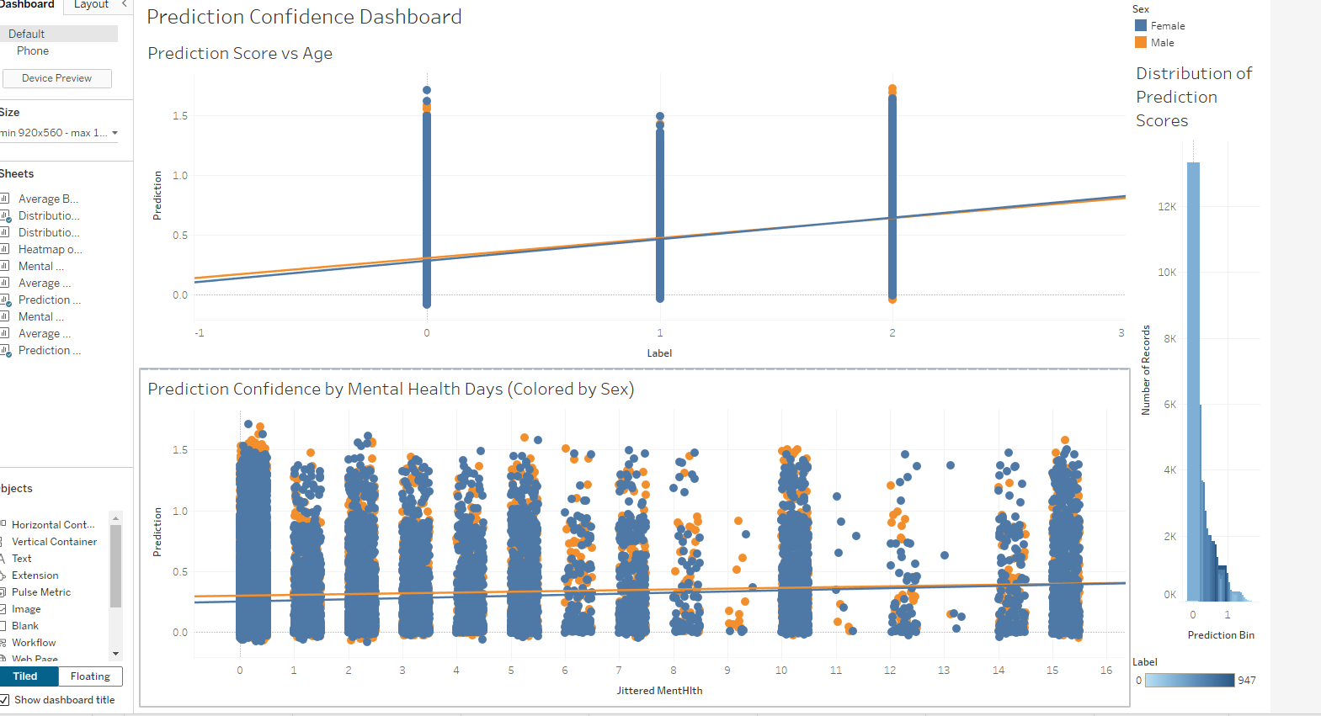

Prediction Confidence Dashboard

This dashboard provides insights into the model’s confidence levels, analyzed through prediction scores in relation to ground-truth labels, mental health days, and overall score distribution.

Prediction Score vs Label (Scatter Plot):

Prediction scores increase progressively with higher risk labels, indicating that the model assigns greater risk to individuals with higher ground-truth classifications. Trend lines confirm consistent behavior across both male and female groups.

Prediction vs Mental Health Days (Jittered Strip Plot):

A subtle upward trend indicates that individuals reporting a higher incidence of mentally unhealthy days are generally associated with moderately elevated prediction scores. While the data points are scattered, the trend line indicates a weak but consistent association between mental health status and predicted risk.

Prediction Score Distribution (Histogram):

The majority of prediction scores are concentrated within the 0.0 to 0.2 range, with only a minimal subset surpassing 0.8. This distribution underscores the model’s inherently conservative disposition, wherein high-confidence predictions are reserved for a select group of individuals identified as high-risk.

Overall, the dashboard substantiates the model’s reliability, demonstrating that it systematically assigns elevated scores in contexts warranting concern, while preserving a judicious stance in designating high-risk classifications..

## 5.7 Key Findings

The exploratory and visual analyses revealed several important insights:

* Strong Predictive Features: Variables such as age, Body Mass Index (BMI), and mentally unhealthy days (MentHlth) showed strong associations with elevated risk predictions, aligning with established clinical risk factors.
* Data Quality: The dataset exhibited minimal missingness and only a moderate degree of class imbalance, supporting the reliability of subsequent modeling efforts.
* Segmented Insights: Visualization tools enabled clear segmentation across demographic and clinical dimensions, facilitating nuanced interpretation of model performance and informing potential directions for targeted intervention.

These findings laid a solid foundation for the modeling phase, ensuring both interpretability and clinical relevance in downstream analyses.

# 8. Discussion

The comparative evaluation of modeling methodologies illuminated critical trade-offs among predictive accuracy, interpretability, and scalability.

• Performance Comparison:

The Random Forest algorithm exhibited markedly superior predictive efficacy relative to Logistic Regression, particularly in discerning intricate, non-linear patterns within the dataset. This advantage manifested in elevated accuracy metrics and enhanced robustness in capturing inter-feature interactions, rendering it more adept at identifying high-risk individuals across heterogeneous subpopulations.

• Interpretability:

Although Logistic Regression provided enhanced interpretability via its linear coefficients and transparent depiction of feature influence, it was limited in its capacity to model non-linear associations. Consequently, its utility in nuanced risk stratification was diminished, despite its continued relevance in clinical decision-making scenarios where explicability remains paramount.

• Scalability and Workflow Efficiency:

The deployment of Apache Spark—specifically through PySpark—was instrumental in addressing the scale of the dataset. Its distributed computing architecture facilitated efficient data processing, while the integration of PySpark pipelines enabled a coherent and reproducible modeling workflow tailored for extensive health data analytics.

To sum up, our analysis highlights the critical need to carefully balance a model's predictive power with how easy it is to understand. The right balance for that trade-off always depends on the specific situation. For voluminous and intricate health datasets, the convergence of scalable computational infrastructure with sophisticated machine learning paradigms can yield actionable insights while preserving operational efficiency.

# 9. Conclusion

This project successfully applied Big Data and machine learning techniques to the task of diabetes risk prediction. By leveraging Apache Spark for scalable data processing and Tableau for effective visualization, an efficient analytical pipeline was developed to handle large-scale healthcare data. Exploratory analysis identified age, BMI, and mental health indicators as significant predictors. The Random Forest model demonstrated strong predictive performance while maintaining interpretability, supporting its potential use in clinical decision-making. These findings underscore the value of data-driven approaches in chronic disease prevention and modern healthcare analytics.

# References

Kaggle. (n.d.). Diabetes Health Indicators Dataset. Retrieved from <https://www.kaggle.com/datasets/alexteboul/diabetes-health-indicators-dataset>

Centers for Disease Control and Prevention (CDC). Behavioral Risk Factor Surveillance System (BRFSS). (Underlying data source for many public health datasets like the Kaggle one, often cited for methodology).

3. Zaharia, M., Ghodsi, A., Shenker, S., & Stoica, I. (2016). Spark: The Definitive Guide: Big Data Processing Made Simple. O'Reilly Media.

4. Ryza, S., Laserson, O., Mozafari, A., & Pal, J. (2015). Advanced Analytics with Spark: Patterns for Learning from Data at Scale. O'Reilly Media.

5. Karau, H., Konwinski, A., Wendell, P., & Zaharia, M. (2015). Learning Spark: Lightning-Fast Big Data Analysis. O'Reilly Media.

6. Chambers, B. (2018). Spark: The Definitive Guide. O'Reilly Media. (Updated editions/authors often exist, good to include the most relevant one).

3. PySpark & Machine Learning Libraries:

7. Mishra, A. (2022). PySpark for Machine Learning: Master Big Data processing and data science with Apache Spark 3 and Python 3. Packt Publishing.

8. Spark MLlib Documentation. (n.d.). Apache Spark official documentation for Machine Learning Library. Retrieved from <https://spark.apache.org/docs/latest/ml-guide.html>

9. Raschka, S., & Mirjalili, V. (2019). Python Machine Learning: Machine Learning and Deep Learning with Python, scikit-learn, and TensorFlow 2. Packt Publishing. (While not purely Spark, foundational for ML concepts used with PySpark).

4. Machine Learning in Healthcare & Early Detection:

10. Kononenko, I., & Kukar, M. (2007). Machine Learning and Data Mining for Medical Applications. IOS Press.

11. Sidey-Gibbons, C. J., & Sidey-Gibbons, J. G. (2019). Machine learning in medicine: a practical introduction. BMC Medical Research Methodology, 19(1), 64.

12. Rajkomar, A., Dean, J., & Kohane, I. S. (2019). Machine Learning in Medicine. New England Journal of Medicine, 380(14), 1347-1358.

13. Esteva, A., Robicquet, B., Ramsundar, N., Kuleshov, V., DePristo, M., Chou, K., ... & Topol, E. J. (2017). Dermatologist-level classification of skin cancer with deep neural networks. Nature, 542(7639), 115-118. (Example of successful ML in clinical context).

14. Subasi, A., Alkan, A., & Koklukaya, E. (2011). Diagnosis of diabetes using neural networks and support vector machines. Expert Systems with Applications, 38(6), 7256-7263. (Specific to diabetes prediction).

15. World Health Organization (WHO). (n.d.). Diabetes Fact Sheets and Reports. Retrieved from <https://www.who.int/news-room/fact-sheets/detail/diabetes>

16. World Health Organization (WHO). (n.d.). Noncommunicable Diseases (NCDs) Fact Sheets and Reports. Retrieved from https<https://www.who.int/news-room/fact-sheets/detail/noncommunicable-diseases>

17. American Diabetes Association (ADA). (n.d.). Standards of Medical Care in Diabetes. (Annual publication, highly authoritative for clinical guidelines).

18. Centers for Disease Control and Prevention (CDC). (n.d.). National Diabetes Statistics Report. Retrieved from <https://www.cdc.gov/diabetes/data/statistics-report/index.html>

19. Lundberg, S. M., & Lee, S. I. (2017). A Unified Approach to Interpreting Model Predictions. Advances in Neural Information Processing Systems, 30.

20. Ribeiro, M. T., Singh, S., & Guestrin, C. (2016). "Why Should I Trust You?": Explaining the Predictions of Any Classifier. Proceedings of the 22nd ACM SIGKDD International Conference on Knowledge Discovery and Data Mining.

# Appendix

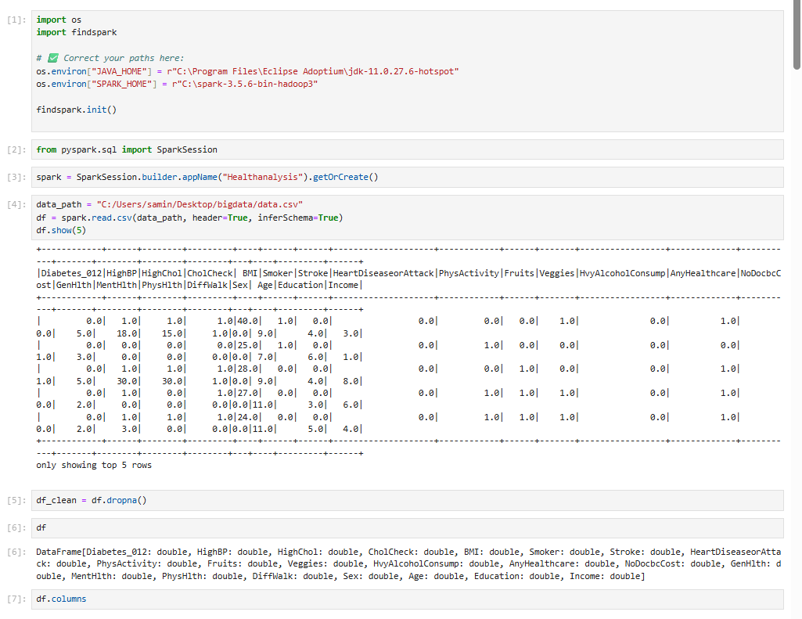

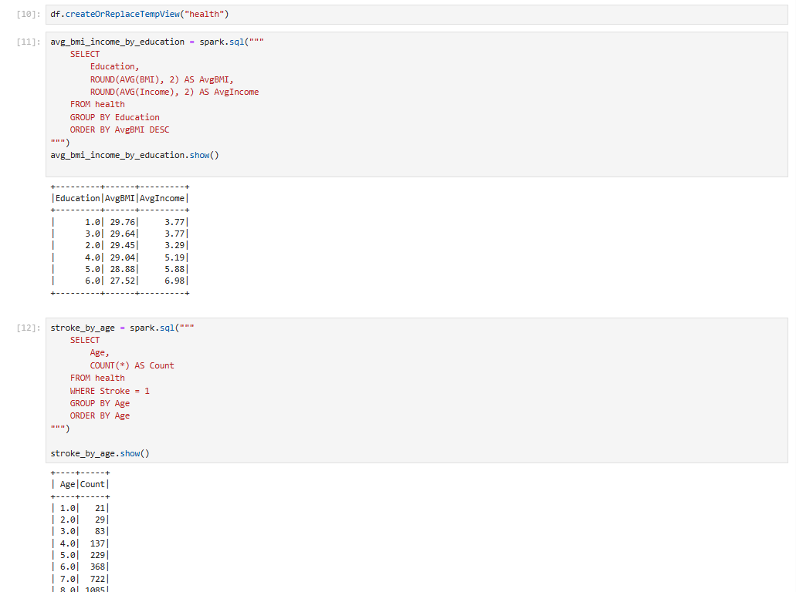

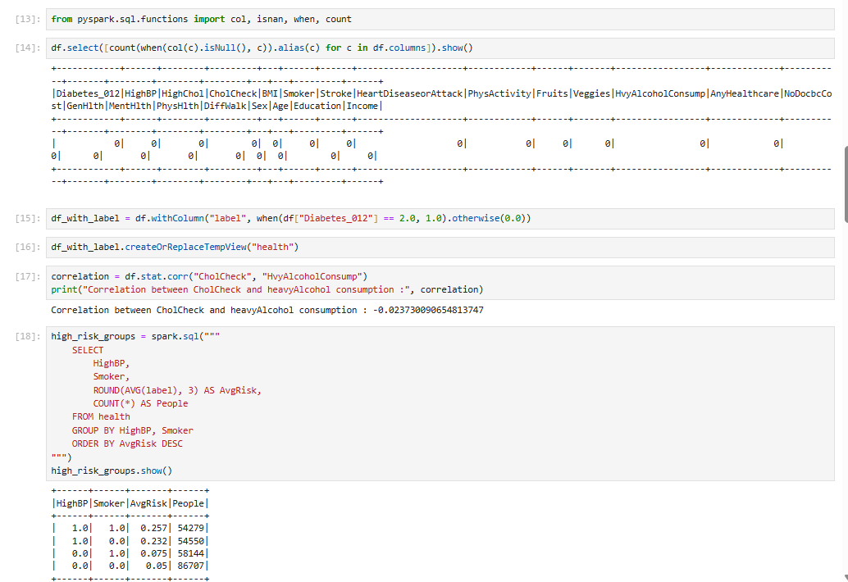

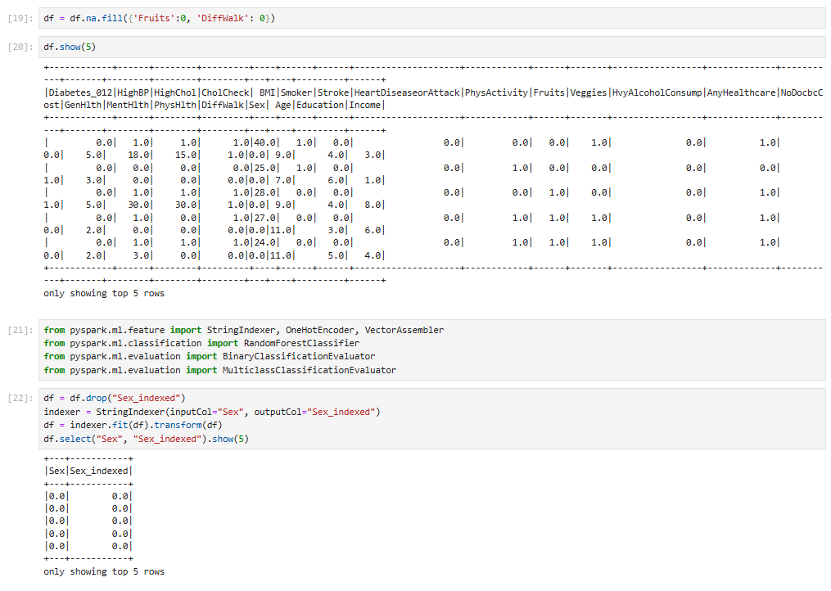

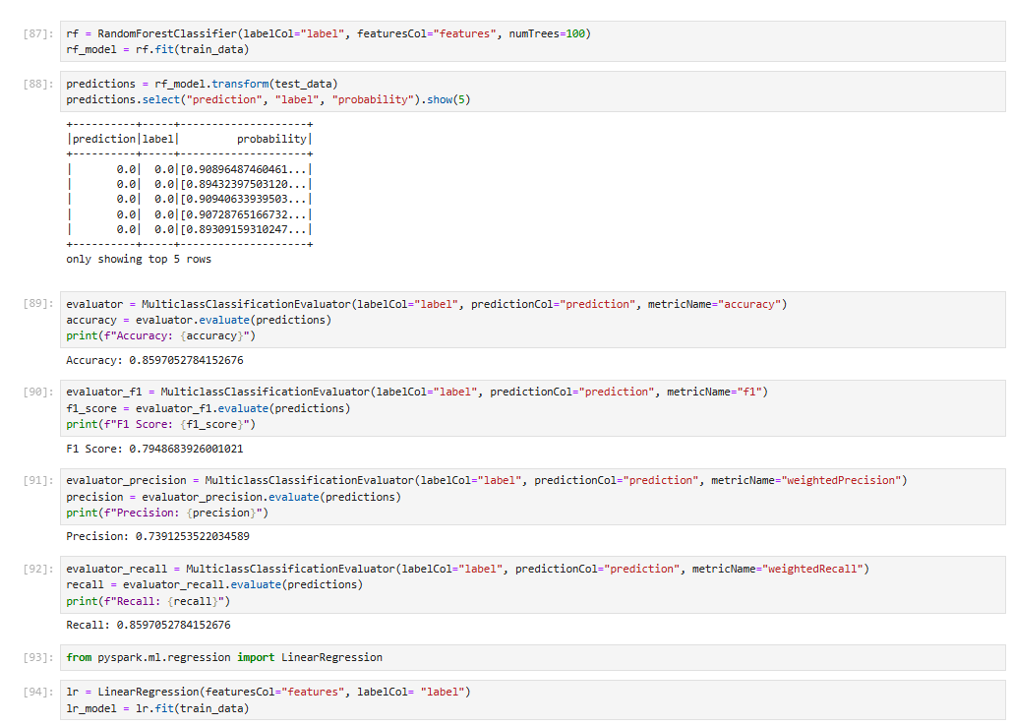

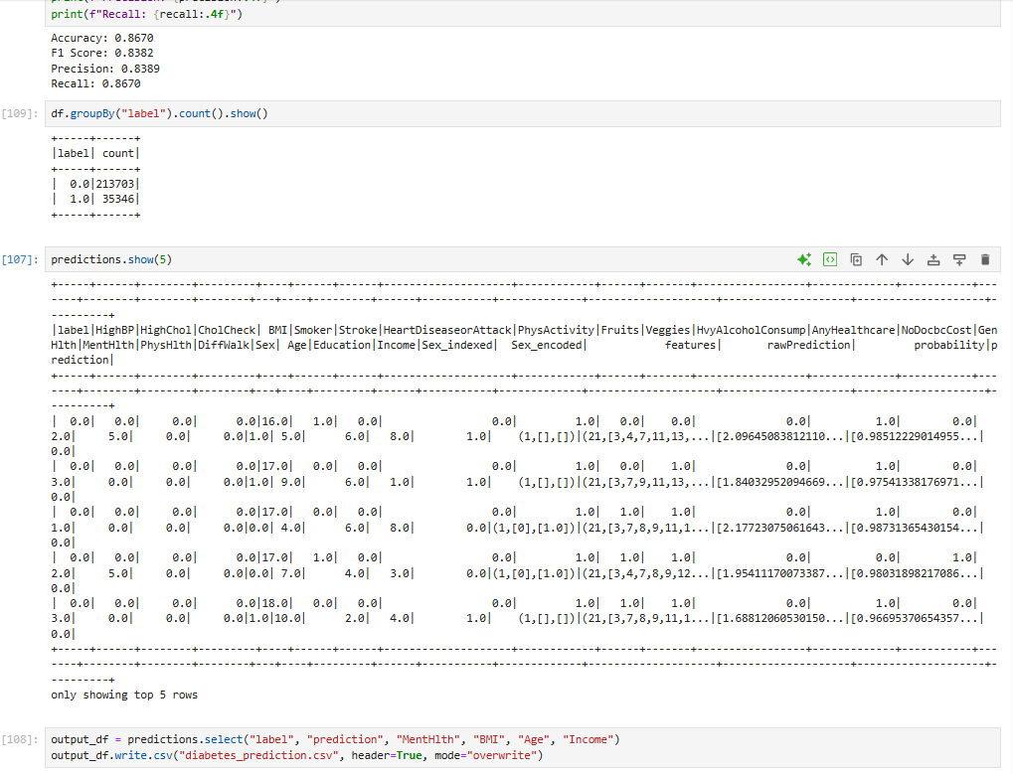

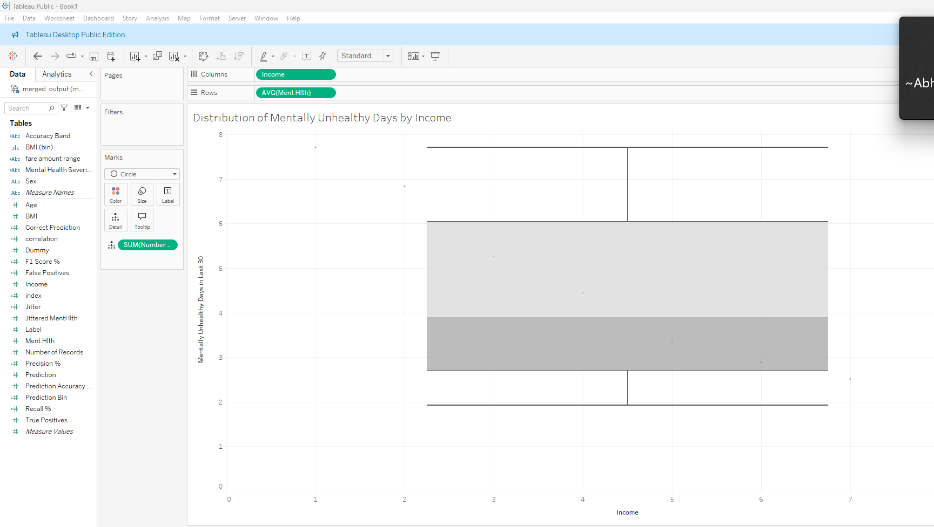

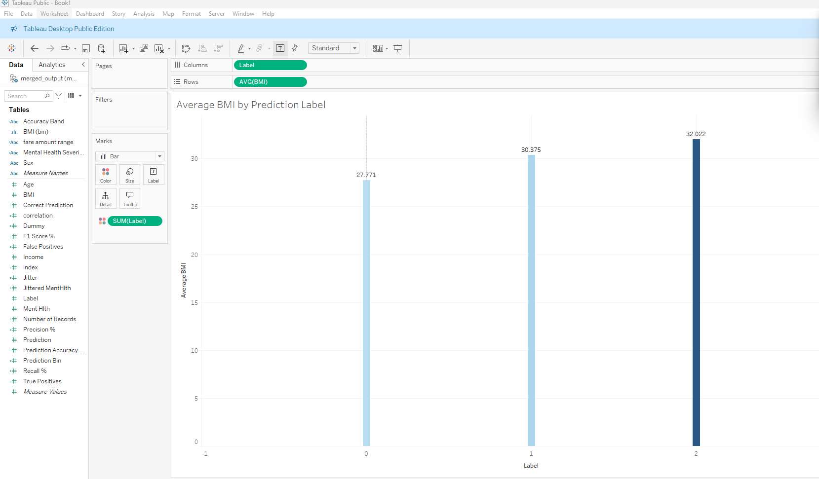

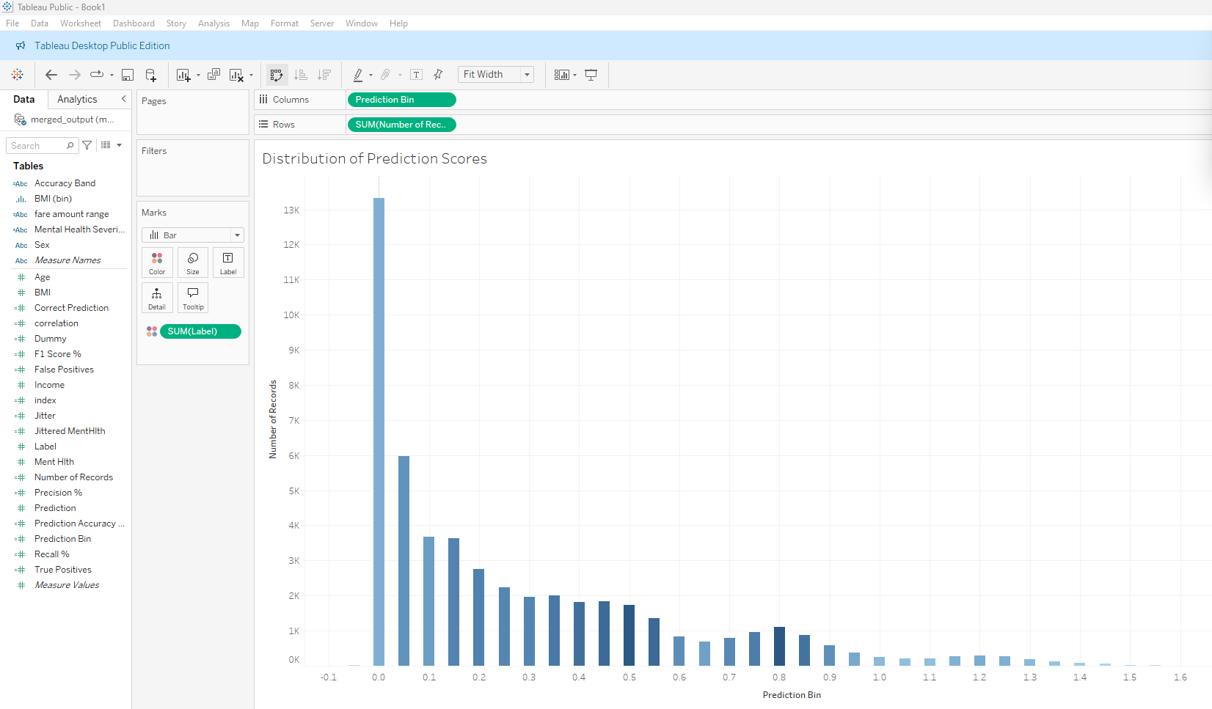

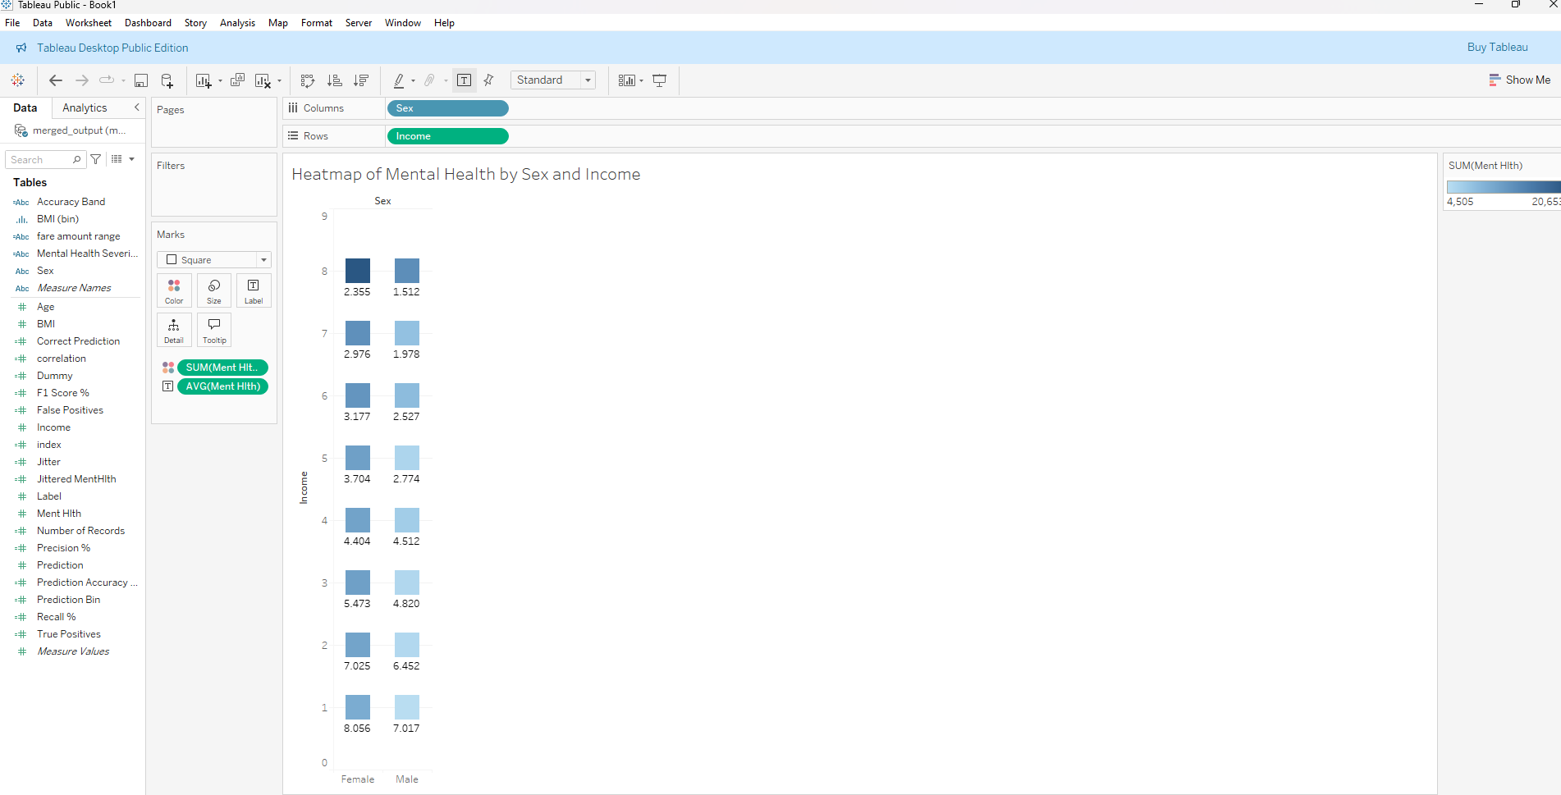



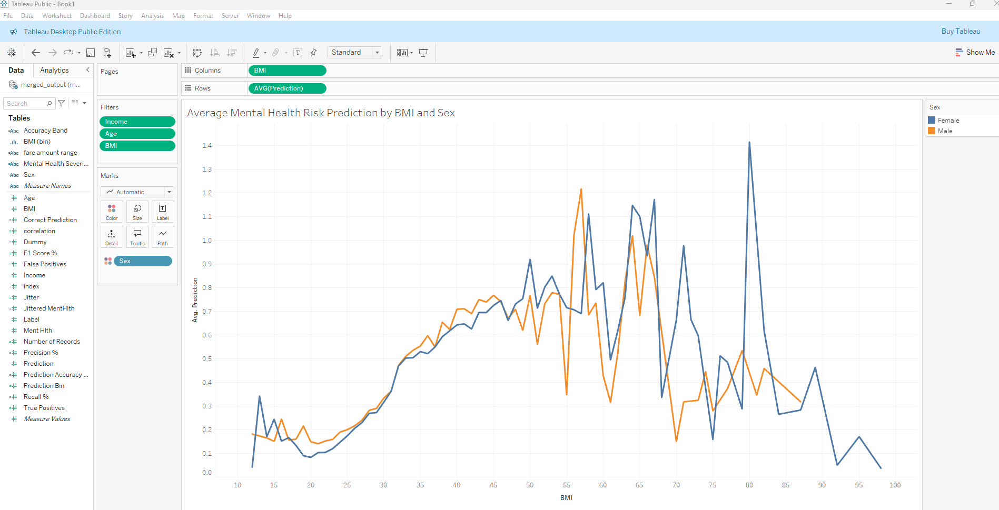

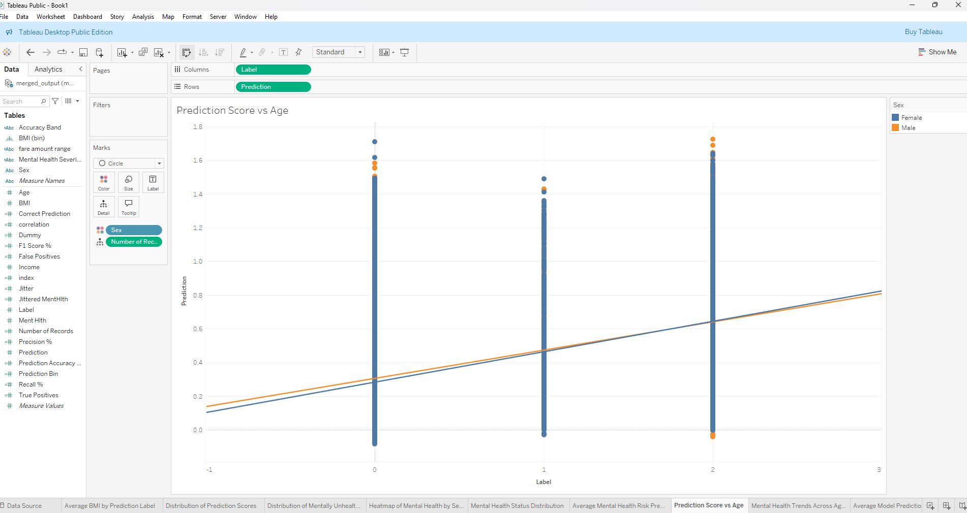

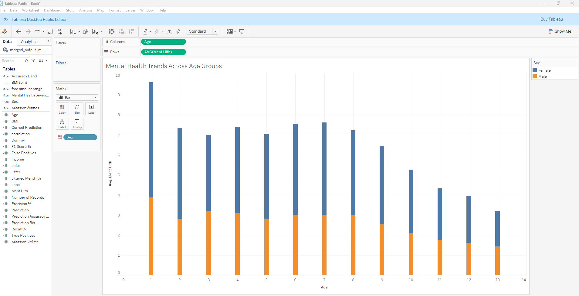

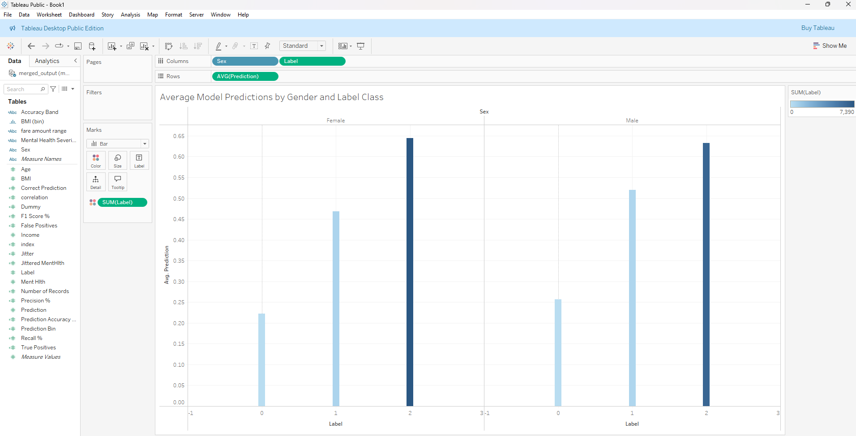

## Link